|  |  |
| --- | --- |
| COURSE MATERIAL | |
| SUBJECT | **ELECTRICAL MEASUREMENTS**  **(15A02501)** |
| UNIT | **1** |
| COURSE | **B.TECH** |
| DEPARTMENT | **ELECTRICAL ENGINEERING** |
| SEMESTER | **31** |
| PREPARED BY  (Faculty Name/s) | **Mr. V G T RAKESH**  **Assistant Professor** |
| Version | **V-1** |
| PREPARED / REVISED DATE | **20-12-2020** |

|  |  |  |  |  |
| --- | --- | --- | --- | --- |
| TABLE OF CONTENTS – UNIT 1 | | | | |
| S. NO | **CONTENTS** | | **PAGE** |
| 1 | **COURSE OBJECTIVES** | | **1** |
| 2 | **PREREQUISITES** | | **1** |
| 3 | **SYLLABUS** | | **1** |
| 4 | **COURSE OUTCOMES** | | **1** |
| 5 | **CO - PO/PSO MAPPING** | | **1** |
| 6 | **LESSON PLAN** | | **2** |
| 7 | **ACTIVITY BASED LEARNING** | | **2** |
| 8 | **LECTURE NOTES** | | **2** |
|  | **1.1** | **INTRODUCTION TO MEASUREMENTS** | **2** |
|  | **1.2** | **CLASSIFICATION OF INSTRUMENTS** | **3** |
|  | **1.3** | **ESSENTIALS OF INDICATING INSTRUMENTS** | **4** |
|  | **1.4** | **PMMC PRINCIPLE OF OPERATION, ERRORS** | **12** |
|  | **1.5** | **EXTENSION OF PMMC INSTRUMENTS** | **15** |
|  | **1.6** | **MOVING IRON TYPE INSTRUMENT-OPERATION-ERRORS** | **17** |
|  | **1.7** | **CATHODE RAY OSCILLOSCOPE- CATHODE RAY TUBE** | **20** |
|  | **1.8** | **TIME BASE GENERATOR-HORIZONTAL AND VERTICAL AMPLIFIERS** | **23** |
|  | **1.9** | **PRINCIPLE MEASUREMENT OF VOLTAGE, CURRENT** | **24** |
|  | **1.10** | **MEASUREMENT OF PHASE , FREQUENCY** | **27** |
|  | **1.11** | **LISSAJOU'S PATTERNS** | **30** |
|  | **1.12** | **APPLICATION OF CRO** | **31** |
| 9 | **PRACTICE QUIZ** | | **32** |
| 10 | **ASSIGNMENTS** | | **33** |
| 11 | **PART A QUESTIONS & ANSWERS (2 MARKS QUESTIONS)** | | **33** |
| 12 | **PART B QUESTIONS** | | **35** |
| 13 | **SUPPORTIVE ONLINE CERTIFICATION COURSES** | | **35** |
| 14 | **REAL TIME APPLICATIONS** | | **35** |
| 15 | **CONTENTS BEYOND THE SYLLABUS** | | **36** |
| 16 | **PRESCRIBED TEXT BOOKS & REFERENCE BOOKS** | | **36** |
| 17 | **MINI PROJECT SUGGESTION** | | **37** |

1. **Course Objectives**

The objectives of this course is to

1. Understand basic principles of all measuring instruments.
2. Measure the basic circuit parameters such as R, L,C
3. Measure the electrical quantities such as voltage, current, power factor, power and energy
4. Understand the operation of instrument transformers and magnetic instruments
5. **Prerequisites**

Students should have knowledge on

1. Electronic Circuit Analysis
2. Basic Electrical Engineering
3. **Syllabus**

**UNIT I**

MEASURING INSTRUMENTS

Classification – Ammeters and Voltmeters – PMMC, Dynamometer, Moving Iron Type Instruments – Expression for the Deflecting Torque and Control Torque – Errors and Compensations, Range Extension. Cathode Ray Oscilloscope- Cathode Ray tube-Time base generator-Horizontal and Vertical Amplifiers – Applications of CRO – Measurement of Phase , Frequency, Current & Voltage- Lissajous Patterns

**4**. **Course outcomes**

1. **Analyze** the principles of various electrical measuring instruments.
2. **Determine** the values of R, L and C using appropriate AC and DC bridges
3. **Measure** the power and energy in single phase and three phase circuits.
4. **Use** C.Ts and P.Ts for measurement of very large currents and high voltages.

**5.Co-PO / PSO Mapping**

|  |  |  |  |  |  |  |  |  |  |  |  |  |  |  |
| --- | --- | --- | --- | --- | --- | --- | --- | --- | --- | --- | --- | --- | --- | --- |
|  | PO1 | PO2 | PO3 | PO4 | PO5 | PO6 | PO7 | PO8 | PO9 | P10 | PO11 | PO12 | PSO1 | PSO2 |
| CO1 |  | 3 |  |  |  |  |  |  |  |  |  | 2 |  |  |
| CO2 | 2 | 3 |  |  |  |  |  |  |  |  |  |  |  |  |
| CO3 | 2 | 3 |  | 2 |  |  |  |  |  |  |  | 2 |  | 2 |
| CO4 |  | 2 |  |  |  |  |  |  |  |  |  | 1 |  | 2 |

**6.Lesson Plan**

|  |  |  |  |
| --- | --- | --- | --- |
| LECTURE | WEEK | TOPICS TO BE COVERED | REFERENCES |
| 1 | **1** | Introduction To Measurements | T1 |
| 2 | Classification Of Instruments | T1, R1 |
| 3 | Essentials Of Indicating Instruments | T1, R1 |
| 4 | PMMC Principle Of Operation, Errors | T1, R1 |
| 5 | **2** | Extension Of PMMC Instruments | T1, R2 |
| 6 | Moving Iron Type Instrument-Operation-Errors | T1, R1 |
| 7 | Cathode Ray Oscilloscope- Cathode Ray Tube | T1, R1 |
| 8 | Time Base Generator-Horizontal And Vertical Amplifiers | T1, R1 |
| 9 | **3** | Principle Measurement Of Voltage, Current | T1, R1 |
| 10 | Measurement Of Phase , Frequency | T1, R1 |
| 11 | Lissajou's Patterns | T1, R1 |
| 12 | Application Of CRO | T1, R1 |

1. **Activity Based Learning**
2. Given Different Types of instruments to the Students. They have to Identify Which Type ,Range and Scale.
3. Measuring Voltage ,Current, Power and Frequency on Cathode Ray Oscilloscope
4. **Lecture Notes**

**1.1** **INTRODUCTION**

Electrical Measurements Are The Methods, Devices And Calculations Used

To Measure Electrical Quantities.

Measurement Of Electrical Quantities May Be Done To Measure Electrical Parameters Of A System.... Electrical Measurements Are A Branch Of The Science Of Metrology.

**1.2** **CLASSIFICATION OF MEASURING INSTRUMENTS**

Electrical measuring instruments are classified into two groups:

1. Absolute (or primary) instruments.

2. Secondary instruments.

**1.Absolute Instruments:**

These instruments give the value of the electrical quantity in terms of absolute quantities (or Some constants) of the instruments and their deflections. In this type of instruments no calibration or comparison with other instruments is necessary. They are generally not used in laboratories and are seldom used in practice by electricians.

Some of the examples of absolute instruments are:

EX: Tangent galvanometer

**2.SECONDARY INSTRUMENTS:**

They are direct reading instruments. The quantity to be measured by these instruments can be determined from the deflection of the instruments. They are often calibrated by comparing them with either some absolute instruments or with those which have already been calibrated. Some of the very widely used secondary instruments are: ammeters, voltmeter, wattmeter, energy meter , ampere-hour meters etc.

secondary instruments are again classified into three types, these are.

1.Indicating instruments

2.Recording instruments

3.Integrating instruments.

**1**.**Indicating Instruments**:

Indicating instruments indicate the quantity to be measured at the time of measurement by means of a pointer which moves on a scale.

Examples are ammeter, voltmeter, wattmeter etc.

**2.Recording Instruments:**

These instruments record continuously the variation of any electrical quantity with respect to specified time. In principle, these are indicating instruments but so arranged that a permanent continuous record of the indication is made on a chart or dial. The recording is generally made by a pen on a graph paper which is rotated on a dice or drum at a uniform speed. The amount of the quantity at any time (instant) may be read from the traced chart. Any variation in the quantity with time is recorded by these instruments.

Examples are ECG and X-Y recorder etc.

**3. Integrating Instruments:**

These instruments record the consumption of the total quantity of electricity, energy etc., during a particular period of time. That is, these instruments measure total energy over a specified period of time. No indication of the rate or variation or the amount at a particular instant are available from them.

Some widely used integrating instruments are: Ampere-hour meter: kilowatt-hour (kWh) meter, etc.

**1.3 : ESSENTIALS OF INDICATING INSTRUMENTS**

Essential that the moving system is acted upon by three distinct torque (or forces) for satisfactory

working. There torques are:

1. A deflecting or operating torque, TD

2. A controlling torque, TC

3. A damping torque,

**1. Deflecting Torque/Force:**

The defection of any instrument is determined by the combined effect of the deflecting torque and control torque. The value of deflecting torque must depend on the electrical signal to be measured. This torque causes the instrument movement to rotate from its zero position. The defection of The deflection torque can be provided by the following methods.

1. **Magnetic effect**:

When a current carrying conductor is placed in a uniform magnetic field, it produces a force it causes to move it. This effect is mostly used in many instruments like permanent magnet moving coil instrument, moving iron instrument etc;

1. **Thermal Effect**:

The current to be measured is passed through a small element (platinum iridium wire ) , the property of the element is, it expanses when the temperature increase. Due to the current flowing through the element, the temperature of the element increases, due to the elasticity property the moving system of the instrument moves from the zero position.

1. **Electrostatic Effects:**

When two charged plates are kept with a small distance , there is a attraction or repulsion force experience between the two plates, this effect is called Electrostatic Effect. This force is used to move the pointer of the instrument.

1. **Induction Effects:**

This type of instrument works on the principle of induction motor. This instruments are used to measure only A.C quantities. When a non-magnetic conducting disc is placed in a magnetic field produced by electromagnets which are excited by alternating currents, an emf is induced in it.

1. **Controlling torque/force:**

This torque must act in the opposite direction to the deflecting torque, and the movement will take up an equilibrium or definite position when the deflecting and controlling torque are equal in magnitude. The controlling torque is dependent on the magnitude of deflection produced. The moving system is deflected from zero to such a position that the controlling torque at that deflected position is equal to the deflecting torque. The controlling torque increases in magnitude with the deflection till it balances the deflecting torque. That is, for a steady deflection,

Controlling torque = Deflection or operating torque,

Then we will get the steady deflection.

The controlling torque developed in an instrument has two functions:

1. It limits the movement of the moving system and ensures that the magnitude of the

deflections always remains the same for a given value of the quantity to be measured.

(b) It brings back the moving system to its zero position when deflection force is zero.

There are two methods to provide controlling torques.

1. Spring controlling torque.
2. Gravity controlling torque.

**1.Spring Control:**

Spring control is now almost universal in indicating instruments. Figure shows a spindle free to turn between two pivots. The moving system is attached to the spindle. Two phosphor-bronze hair springs wound in opposite directions are also shown whose inner ends are attached to the spindle. The outer end of spring one of the spring is connected to a leaver which is pivoted the adjustment of which gives zero setting. However, the outer end of another is fixed. When the pointer is deflected one spring unwinds itself while the other is twisted. This twist in the spring produces restoring (controlling) torque, which is proportional to the angle of deflection of the moving systems.

The springs used for controlling torque should have following properties.

1. The spring should be non magnet.
2. The spring should be free from mechanical stress.
3. The spring should have a small resistant, sufficient cross sectional area.
4. It should have low resistive temperature coefficient.

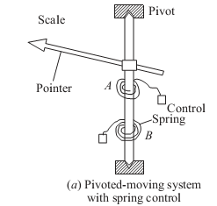

The controlling Torque produced by spring is given by,

Where KS is the spring constant =

**2.Gravity Control:**

In gravity controlled instruments, as shown in Fig. (a) a small adjustable weight is attached to the spindle of the moving system such that the deflecting torque produced by the instrument has to act against the action of gravity. Thus a controlling torque is obtained. This weight is called the control weight. Another adjustable weight is also attached is the moving system for zero adjustment and balancing purpose. This weight is called Balance weight. When the control weight is in vertical position as shown in Fig. (a), the controlling torque is zero and hence the pointer must read zero. However, if the deflecting torque lifts the controlling weight from position A to B as shown in Fig. (b) such that the spindle rotates by an angle θ, then due to gravity a restoring (or controlling) torque is exerted on the moving system.

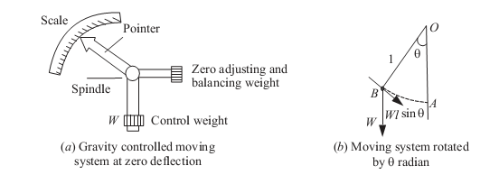

The controlling torque, TC, is given by

TC= Wl sin =Kg sin

Where W is the control weight

L is the distance of control weight from the axis of rotation of moving system

Kg is the gravity constant.

This relation shows that current I is proportional to sin θ and not θ. Hence in gravity controlled instruments the scale is not uniform. It is cramped for the lower readings, instead of being uniformly divided, for the deflecting torque assumed to be directly proportional to the quantity being measured.

**Advantages Of Gravity Control:**

1. It is cheap and not affected by temperature variations.

2. It does not deteriorate with time.

3. It is not subject to fatigue.

**Disadvantages Of Gravity Control:**

1. Since the controlling torque is proportional to the sine of the angle of deflection, the scale is not uniformly divided but cramped at its lower end.

2. It is not suitable for use in portable instruments (in which spring control is always preferred).

3. Gravity control instruments must be used in vertical position so that the control weight may operate and also must be leveled otherwise they will give zero error.

In these reasons, gravity control is not used for indicating instruments in general.

**4. Damping torque/force:**

A damping force is required to act in a direction opposite to the movement of the moving system. This brings the moving system to rest at the deflected position reasonably quickly without any oscillation or very small oscillation.

This is provided by

1. air friction damping

2. fluid friction damping

3.eddy current damping



Depending upon the degree of damping introduced in the moving system, the instrument may have any one of the following conditions as depicted in Fig.

1. Under damped condition: The response is oscillatory

2. Over damped condition: The response is sluggish and it rises very slowly from its zero

position to final position.

3. Critically damped condition: When the response settles quickly without any oscillation, this system is said to be critically damped. In practice, the best response is slightly obtained when the damping is below the critical value the instrument is slightly under damped.

The damping torque is produced by the following methods:

1. **Air Friction Damping:**

The arrangement of Fig. consists of a light aluminum piston which is attached to the moving system. This piston moves in a fixed chamber which is closed at one end. Either circular or rectangular chamber may be used. The clearance (or gap) between the piston and chamber walls should be uniform throughout and as small as possible. When the piston moves rapidly into the chamber the air in the closed space is compressed and the pressure of air thus developed opposes the motion of the piston and thereby the whole moving system. If the piston is moving out of the chamber, rapidly, the pressure in the closed space falls and the pressure on the open side of the piston is greater than that on the opposite side. Motion is thus again opposed. With this damping system care must be taken to ensure that the arm carrying the piston should not touch the sides of the chamber during its movement. The friction which otherwise would occur may introduce a serious error in the deflection.



Fig: Air Friction Damping

The air friction damping is very simple and cheap. But care must be taken to ensure that the piston is not bent or twisted. This method is used in moving iron and hot wire instruments.

1. **Fluid Friction Damping:**

This form is damping is similar to air friction damping. The action is the same as in the air friction damping. Mineral oil is used in place of air and as the viscosity of oil is greater, the damping force is also much greater. The vane attached to the spindle is arranged to move in the damping oil.

• It is rarely used in commercial type instruments.

• The oil used must fulfill the following requirements.

* It should not evaporate quickly

* It should not have any corrosive effect on metals.

* Its viscosity should not change appreciably with temperature.

* It should be good insulator.

Arrangements of fluid damping are shown in Fig.

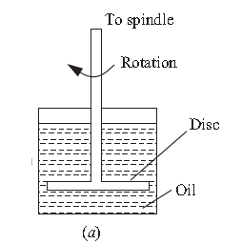

In Fig. (a) a disc attached to the moving system is immersed in the fluid (damping oil). When the moving system moves the disc moves in oil and a frictional drag is produced. For minimizing the surface tension affect, the suspension stem of the disc should be cylindrical and of small diameter.

**Advantages of Fluid Friction Damping**

1. The oil used for damping can also be used for insulation purpose in some forms of instruments which are submerged in oil.

2. The clearance between the vanes and oil chamber is not as critical as with the air friction clamping system.

3. This method is suitable for use with instruments such as electrostatic type where the movement is suspended rather than pivoted.

4. Due to the up thrust of oil, the loads on bearings or suspension system is reduced thereby the reducing the frictional errors.

**Disadvantages of Fluid Friction Damping**

1. The instruments with this type of damping must be kept always in a vertical position.

2. It is difficult to keep the instrument clean due to leakage of oil.

3. It is not suitable for portable instruments.

**3. Eddy Current Damping**

Eddy current damping is the most efficient form of damping. The essential components in this type of damping are a permanent magnet; and a light conducting disc usually of aluminum.



When a sheet of conducting material moves in a magnetic field so as to cut through lines of force, eddy currents are set up in it and a force exists between these currents and the magnetic field, which is always in the direction opposing the motion. This force is proportional to the magnitude of the current, and to the strength of field. The former is proportional to the velocity of movement of the conductor, and thus, if the magnetic field is constant, the damping force is proportional to the velocity of the moving system and is zero when there is no movement of the system.

**1.4:PMMC PRINCIPLE OF OPERATION, ERRORS**

The general theory of moving-coil instruments may be dealt with considering a rectangular coil of turns, free to rotate about a vertical axis. Fig shows the basic construction of a PMMC instrument. A moving coil instrument consists basically of a permanent magnet to provide a magnetic field and a small lightweight coil is wound on a rectangular soft iron core that is free to rotate around its vertical axis. When a current is passed through the coil windings, a torque is developed on the coil by the interaction of the magnetic field and the field set up by the current in the coil. The aluminum pointer attached to rotating coil and the pointer moves around the calibrated scale indicates the deflection of the coil. To reduce parallax error a mirror is usually placed along with the scale. A balance weight is also attached to the pointer to counteract its weight in Fig. .

To use PMMC device as a meter, two problems must be solved. First, a way must be found to return the coil to its original position when there is no current through the coil. Second, a method is needed to indicate the amount of coil movement. The first problem is solved by the use of hairsprings attached to each end of the coil as shown in Fig. . These hairsprings are not only supplying a restoring torque but also provide an electric connection to the rotating coil. With the use of hairsprings, the coil will return to its initial position when no current is flowing though the coil. The springs will also resist the movement of coil when there is current through coil.

When the developing force between the magnetic fields is exactly equal to the force of the springs, the coil rotation will stop. The coil set up is supported on jeweled bearings in order to achieve free movement. Two other features are considered to increase the accuracy and efficiency of this meter movement. First, an iron core is placed inside the coil to concentrate the magnetic fields. Second, the curved pole faces ensure the turning force on the coil increases as the current increases. 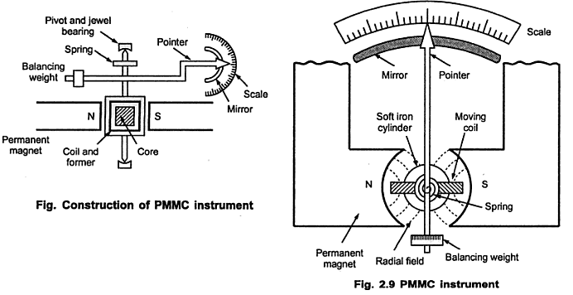**Principle Of Operation**:

It has been mentioned that the interaction between the induced field and the field produced by the permanent magnet causes a deflecting torque, which results in rotation of the coil. The deflecting torque produced is described below in mathematical form.

**Deflecting Torque:**

It is assumed that the coil sides are situated in a uniform radial magnetic field of flux density B wb/ m2, let the length of a coil side (within the magnetic field) be L(meter), and the distance from each coil side to the axis be d (meter).

If the coil is carrying a current of I amps, the force on a coil side = BNAI N-m

Td=GI N-m

Where G=BNA=constant

B= Flux Density in air gap in Wb/m2

A= Effective coil area in m2

I= Current Amps.

Control torque is provided by springs and it is proportional to Angular deflection of the Pointer

TC=Kθ

At steady state condition

Tc=Td

Kθ=GI

θ=

Deflection is directly proportional to current passing through the coil.

**ADVANTAGES:**

1. The scale is uniformly divided .
2. The power consumption can be made very low a
3. The torque-weight ratio can be made high with a view to achieve high accuracy.
4. A single instrument can be used for multi range ammeters and voltmeters.
5. Error due to stray magnetic field is very small.

**DISADVANTAGES:**

1. They are suitable for direct current only.
2. The instrument cost is high.
3. Variation of magnet strength with time.

**1.5 EXTENSION OF INSTRUMENT RANGES**

Moving coil instruments , which are used as ammeters and voltmeters are designed to carry max. current of 50mA and withstand a voltage of 50mV. Hence, to measure larger currents and voltages, the ranges of these meters have to be extended. The following methods are employed to increase the ranges of ammeters and voltmeters

By using shunts, the range of dc ammeters is extended

By using multipliers, the range of dc voltmeter is extended

By using current transformers the range of ac ammeter is extended

By using potential transformer the range of ac voltmeter

By using shunts the range of dc ammeters is extended as follows:

When heavy currents are to be measured , the major part of current if bypassed through a low resistance called shunt. It is shown in the below fig

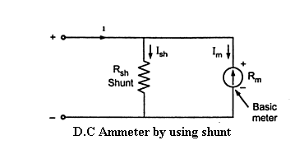

The shunt resistance can be calculated as

Let

Rm = internal resistance of coil

Rsh = shunt resistance

Im = full scale deflection current

Ish = shunt current

I = Total current

Now, I = Ish + Im

Ish Rsh = ImRm

Rsh = ImRm/Ish

Rsh = Rm / (I/Im - 1)

Rsh = Rm / m-1 where m = I/Im

And m is called multiplying power of shunt and is defined as the ratio of total

current to the current through the coil

**Multi range ammeters**

The range of basic dc ammeter can be extended by using no. of shunts and a

selector switch, such a meter is called multi range ammeter and is shown in the fig

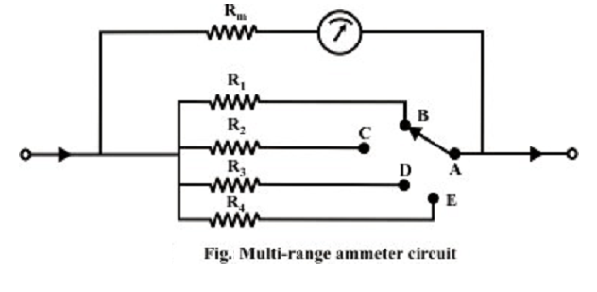

A multi range ammeter can be constructed simple by employing several values of shunt resistances, with a rotary switch to select the desired range. Fig. shows the circuit arrangement.

**Range extension of voltmeter by using Multiplier:**

The resistance is required to be connected in series with basic meter to use it as a voltmeter. This series resistance is called a multiplier. The main function of the multiplier is to limit the current through the basic meter, so that meter current does not exceed full scale deflection value.

The multiplier resistance can be calculated as

Let Rm is the internal resistance of the coil.

Rs = series multiplier resistance

Im = full scale deflection current

V = full range voltage to be measured

V = Im Rm + ImRs

ImRs = V –ImRm / Im

Rs = V/Im - Rm

The multiplying factor for multiplier is the ratio of full range voltage to be

measured and the drop across the basic meter

**1.6 MOVING-IRON TYPE INSTRUMENTS:**

The brief description of different components of a moving-iron instrument is given below.

**Moving element**: a small piece of soft iron in the form of a vane or rod

**Coil:** to produce the magnetic field due to current flowing through it and also to magnetize the iron pieces. Control torque is provided by spring or weight (gravity) Damping torque is normally pneumatic, the damping device consisting of an air chamber and a moving vane attached to the instrument spindle. Deflecting torque produces a movement on an aluminum pointer over a graduated scale.

There are two types of moving iron instruments

1. **Attraction type moving iron instrument**
2. **Repulsion type moving iron instrument**

The deflecting torque in any moving-iron instrument is due to forces on a small piece of magnetically ‘soft’ iron that is magnetized by a coil carrying the operating current. In repulsion (Fig). type moving–iron instrument consists of two cylindrical soft iron vanes mounted within a fixed current-carrying coil. One iron vane is held fixed to the coil frame and other is free to rotate, carrying with it the pointer shaft. Two irons lie in the magnetic field produced by the coil that consists of only few turns if the instrument is an ammeter or of many turns if the instrument is a voltmeter. Current in the coil induces both vanes to become magnetized and repulsion between the similarly magnetized vanes produces a proportional rotation. The deflecting torque is proportional to the square of the current in the coil, making the instrument reading is a true ‘RMS’ quantity Rotation is opposed by a hairspring that produces the restoring torque. Only the fixed coil carries load current, and it is constructed so as to withstand high transient current. Moving iron instruments having scales that are nonlinear and somewhat crowded in the lower range of calibration. Another type of instrument that is usually classed with the attractive types of instrument is shown in (Fig).

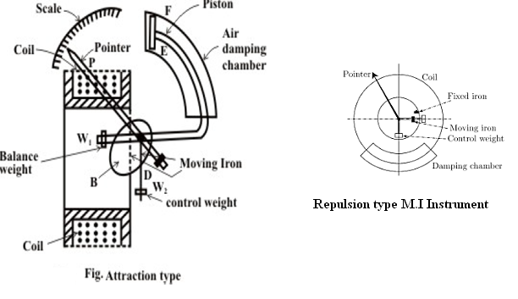

This instrument consists of a few soft iron discs (B) that are fixed to the spindle (D), pivoted in jeweled bearings. The spindle (P) also carries a pointer (P), a balance weight (W1), a controlling weight (W2) and a damping piston (E), which moves in a curved fixed cylinder (F). The special shape of the moving-iron discs is for obtaining a scale of suitable form.

**Torque Expressions:**

Torque expression may be obtained in terms of the inductance of the instrument. Suppose the initial current is I, the instrument inductance L and the deflection θ.

Then let I change to I+ Id, Id being a small change of current; as a result let θ changes to (θ+d θ) and (L+dL) . In order to get an incremental change in current dI there must be an increase in the applied voltage across the coil.

Applied voltage v= = I +

The electric energy supplied to the coil in dt is

vI dt=I2dL+ILdI

Increase in Energy Stored in Magnetic Field=(I+dI)2(L+dL)-I2L

=ILdI+I2dL

(neglecting second and higher terms in small quantities)

If T is the value of the control torque corresponding to deflection θ, the extra energy stored in the control due to the change dθ is Tdθ. Then, the stored increase in stored energy=ILdI+I2dL+Tdθ

From principle of the conservation of energy, one can write the following expression Electric energy drawn from the supply = increase in stored energy + mechanical work done

I2dL+ILdI=ILdI+I2dL+Tdθ

T =I2(NM)

While the controlling torque is given by

TC= Kθ

K= spring constant

Under steady state condition TC=Td

Kθ=

**Advantages:**

1. The instruments are suitable for use in AC and DC circuits.

2. The instruments are robust, owing to the simple construction of the moving parts.

3. The stationary parts of the instruments are also simple.

4. Instrument is low cost compared to moving coil instrument.

5. Torque/weight ratio is high, thus less frictional error.

**Disadvantages:**

1. Scale is not uniform.
2. Error due to variation of frequency causes change of reactance of the coil and also

changes the eddy currents induced in neighboring metal.

1. Deflecting torque is not exactly proportional to the square of the current due to

non-linear characteristics of iron material.

1. Frequency error present in the moving iron instrument.

**1.7 CATHODE RAY OSCILLOSCOPE**

1.Cathode Ray Tube (CRT)

This is the cathode ray tube which is the heart of CR.O. It is' used to emit the electrons required to strike the phosphor screen to produce the spot for the visual display of the signals. The CRT generates the electron beam, accelerates the beam, deflects the beam and also has a screen where beam becomes visible, as a spot. The main parts of the CRT are:

1. Electron gun ii) Deflection system

iii) Fluorescent screen iv) Glass tube or envelope

v) Base

A schematic diagram of CRT, showing its structure and main components is shown in the Fig.

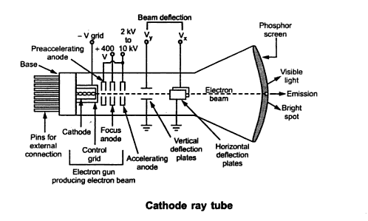

**Electron Gun:**

The electron gun section of the cathode ray tube provides a sharply focused electron beam directed towards the fluorescent-coated screen. This section starts from the cathode, The control grid is given negative potential with respect to cathode dc. This grid controls the number of electrons in the beam, going to the screen. The momentum of the electrons determines the intensity, or brightness, of the light emitted from the fluorescent screen due to the electron beam. The light emitted is usually of the green color. Because the electrons are negatively charged, a repulsive force is created by applying a negative voltage to the control grid (in CRT, voltages applied to various grids are stated with respect to cathode, which is taken as common point).

**Deflection System**

When the electron beam is accelerated it passes through the deflection system, with which beam can be positioned anywhere on the screen. The deflection system of the cathode-ray-tube consists of two pairs of parallel plates, referred to as the vertical and horizontal deflection plates. One of the plates' in each set is connected to ground (0 V), To the other plate of each set, the external deflection voltage is applied through an internal adjustable gain amplifier stage, To apply the deflection voltage externally, an external terminal, called the Y input or the X input, is available. As shown in the Fig. , the electron beam passes through these plates. A positive voltage applied to the Y input terminal (Vy) causes the beam to deflect vertically upward due to the attraction forces, while a negative voltage applied to. The Y input terminal will cause the electron beam to deflect vertically downward, due to the repulsion forces. When the voltages are applied simultaneously to vertical and horizonta1 deflecting plates, the electron beam is deflected due to the resultant-of these two voltages.

**Fluorescent Screen**

The light produced by the screen does not disappear immediately when bombardment by electrons ceases, i.e., when the signal becomes zero. The time period for which the trace remains on the screen after the signal becomes zero is known as "persistence". The persistence may be short as a few microseconds, or as long as tens of seconds or minutes. Long persistence traces are used in the study of transients. Long persistence helps in the study of transients since the trace is still seen on the screen after the transient has disappeared.

**Glass tube:**

All the components of a CRT are enclosed in an evacuated glass tube called envelope. This allows the emitted electrons to move about freely from one end of the tube to other end.

**Base:**

The base is provided to the CRT through which connections are made to the various parts.

**2. Cathode ray oscilloscope (CRO):**

The oscilloscope is, in fact, a voltmeter. Instead of the mechanical deflection of a metallic pointer as used in the normal voltmeters, the oscilloscope uses the movement of an electron beam against a fluorescent screen, which produces the movement of a visible spot. The movement of such spot on the screen is proportional to the varying magnitude of the signal, which is under measurement.

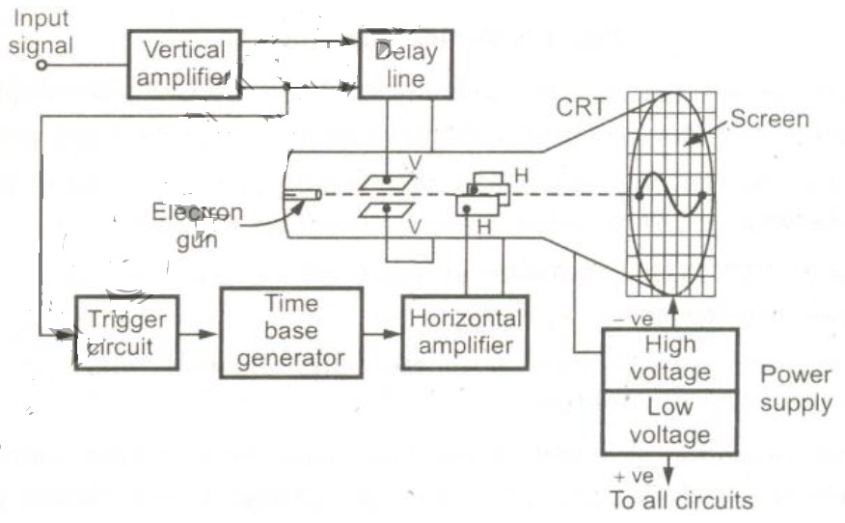

**Vertical Amplifier:**

The input signals are generally not strong to provide the measurable deflection on the screen. Hence the vertical amplifier stages are used to amplify the input signals. The amplifier stages used are generally wide band amplifiers so as to pass faithfully the entire band of frequencies to be measured. Similarly it contains the attenuator stages as well. The attenuators are used when very high voltage signals are to be examined, to bring the signals within the proper range of operation.

**Horizontal amplifier:**

The saw tooth voltage produced by the time base generator may not be of sufficient strength. Hence before giving it to the horizontal plates, it is amplified using the horizontal amplifier.

**Trigger circuit:**

It is necessary that horizontal deflection starts at the same point of the input vertical signal, each time it sweeps. Hence to synchronize horizontal deflection with vertical deflection a synchronizing or triggering circuit is used. It converts the incoming signal into the triggering pulses, which are used for the synchronization.

**1.8 TIME BASE GENERATOR-HORIZONTAL AND VERTICAL AMPLIFIERS**

The time base generator is used to generate the saw tooth voltage, required to deflect the beam in the horizontal section. This voltage deflects the spot at a constant time dependent rate. Thus the x-axis' on the screen can be represented as time, which, helps to display and analyze the time varying signals.

**Delay line:**

The delay line is used to delay the signals for some time in the vertical sections. When the delay line is not used the part of the signals gets lost. Hence the input signal is not applied directly to the vertical amplifier, but it is delayed by some time by using delay line circuit.

There are two types of delay lines used in CRO.

1. Lumped parameter delay line.

2. Distributed parameter delay line.

**Power supply:**

The power supply block provides voltage to CRT to generate an electron beam and to the other circuits like horizontal amplifier and vertical amplifier.

There are two sections of power section block.

1. High voltage section
2. Low voltage section

The high voltage of the order of 1000 to 1500 volts and low voltage of the order of about 500 volts.

**1.9 PRINCIPLE MEASUREMENT OF VOLTAGE AND CURRENT**

**Voltage & Current measurement:**

* CRO includes the amplitude measurement facilities, such as constant gain amplifier and calibrated shift controls.
* The wave form can be adjusted on the screen by using shift controls so that measurement of divisions corresponding to the amplitude becomes easy.
* Generally to reduce the error peak to peak value of the signal is measured than its amplitude and r.m.s value is calculated
* To measure the amplitude use the following steps

1. Note down the selection in volts/division from the front panel, selected for measurement
2. Adjust shift control to adjust signal on the screen so that it becomes easy to count number of divisions corresponding to peak to peak value of the signal
3. Note down peak to peak value in terms the number of divisions on screen
4. Use the following relations

Peak to peak voltage = Vp.p = No. of divisions x

Amplitude =

R.M.S value of signal = =

**Problem 1:**

Calculate the amplitude and R.M.S value of the sinusoidal voltage, the waveform of which is observed on CRO as shown in the figure, the vertical attenuation selected is 2mv/div

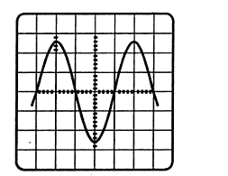

Ans:

It can be observed that the screen is divided such that one part is subdivided into 5 units

1 subdivision = units

Positive peak = 2+3x0.2 = 2.6

Negative peak = 2+3x0.2 = 2.6

peak to peak = 2.6+2.6 = 5.2 divisions

= 5.2 x 2 x

= 10.4mV

**Current measurements:**

CRO is basically voltage indicating device.

Hence to measure the current, the current is passed through a standard resistance is known. The voltage across resistance is displayed on the screen and is measured.

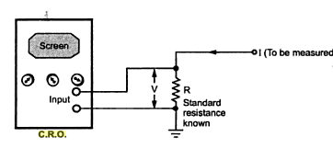

This measured voltage divided by the known resistance gives the value of unknown current

I =

**Problem 2:**

In an experiment the voltage across a 10 K resistor is applied to C.R.O. The screen shows a sinusoidal signal of total vertical accupancy 3 cm and total horizontal occupancy of 2 cm. The front panel controls of V/div and time/div are an 2v/div and 2ms/div

Ans:

Volt/div = 2

Time base = 2ms/div

Voltage occupancy = 3 cm = 3 divisions

= 2x3 = 6 V

= 6/2 = 3 V

Assume that one cycle is displayed on the screen horizontal occupancy = 2 cm = 2 divisions

T = (time/div) x [No. of divisions]

= 2xx2

= 4x

**1.10 MEASUREMENT OF PHASE AND FREQUENCY**

In such measurements, the waveform is displayed on the screen such that are complete cycle is visible on the screen.

Thus accuracy increases if the single cycle occupies as much as the horizontal distance on the screen.

T = [No. of divisions occupied by 1 cycle] x

= Time period

The frequency is the reciprocal of the time period f =

3 1. Measurement of Phase difference:

Consider the lissajous fig. obtained on the CRO. With an unknown phase difference as shown in the figure a.

The frequency and amplitudes of two waves is same

The parameter’s can be measured in fig a.

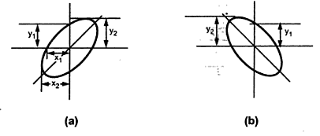

The phase angle then calculated as

If the pattern obtained is as shown in the figure b. then the phase angle is given by

- Sin

**2.Measurement of Frequency:**

To measure the unknown frequency of the signal with known frequency is applied to vertical deflecting plates called known frequency signal is applied to horizontal deflection plates

Using shift control, stationary lissajous is obtained on the screen, such that to the figure vertical and horizontal axes are tangential to one or more points

The pattern depends on the ratio of two frequencies

If the ratio of two frequencies is not integral than the pattern is obtained as shown figure

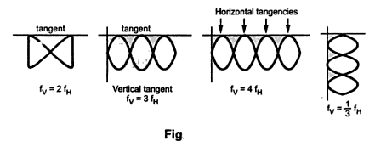

It can be seen that the horizontal frequencies are 3 while vertical tangencies are two

Hence = = 1.5

The lissajous figure obtained on the CRO is shown in the figure, find the phase difference between two applied voltages.

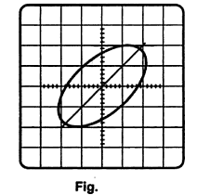

Ans:

It can be observed from the lissajous figures that

= 8 units

10 units

**1.11 LISSAJOUS PATTERNS:**

This methods quickest method of measuring the frequency. In this method standard known frequency signal is applied to the horizontal plates and simultaneously unknown frequency signal is applied to the vertical plates such pattern’s obtained by applying simultaneously two different sine wave to horizontal and vertical deflection plates. This pattern are called Lissajous patterns (or) Lissajous figures the shape of the lissajous figures depends on

1. Amplitude of two waves
2. Phase difference between two waves
3. Ratio of frequency of two waves

Consider two signals applied, having same amplitude and frequency having phase difference of between them.

And

. The phase difference produces the various patterns

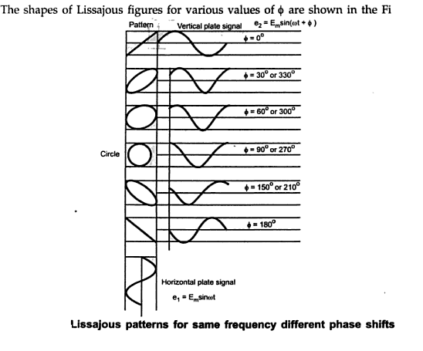

**1.12 APPLICATION OF CRO:**

1. It is used to measure AC as well as DC voltages and currents
2. It is useful to calculate the parameters of the voltages as peak to peak value, r.m.s value etc
3. It is used the measure capacitance, inductance and also used to check the diodes.
4. It is used to measure frequency, time period and phase difference for periodic and non periodic wave forms
5. In the medical application, it is used to display the cardiograms which are useful for the heart beats of the patient
6. In industry, it is used for many purposes. It is used to observe B-H curves, P-V diagrams and other effects

**Problem**:

The Lissajous pattern obtained on the screen by applying horizontal signal of frequency of 1 KHz as shown in the figure. Determine the unknown frequency of vertical signal

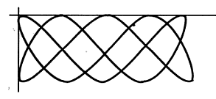

Sol:

It can be observed that

No. of vertical tangencies = 2

No. of horizontal tangencies = 5

=

**9. Practice Quiz**

1. **Which of the following is recording instrument?**
2. Voltmeter
3. Ammeter
4. Energy meter
5. ECG
6. **Electrostatic type instruments are primarily used as**
7. **Voltmeter**
8. Ammeter
9. Energy meter
10. Watt meter
11. **Torque to weight ratio in an Analog instruments indicates**
12. **Frictional error**
13. Frequency error
14. Stray magnetic field error
15. None of these
16. **Range of PMMC voltmeter is extended by using**
17. Shunts
18. **Multipliers**
19. Both
20. None
21. **Spring are made with-------------material.**
22. Soft iron
23. Steel
24. **Phosphor bronze**
25. Silicon steel
26. **Moving iron instrument is used for--------**
27. D.C only
28. A.C only
29. **Both A.C and D.C**
30. None of these
31. **Range of PMMC Ammeter is extended by using**
32. **Shunts**
33. Multipliers
34. Both
35. None
36. **In an electro dynamometer type wattmeter’s**
37. The current coli is made fixed
38. **The pressure coil is made fixed**
39. Any of the two coils made fixed
40. Both of the coils should be movable
41. **In a spring controlled iron instruments, the scale is**
42. Uniform
43. **Cramped at the lower end expanded at the upper end**
44. Cramped at the upper end expanded at the lower end
45. Expanded both upper and lower end.
46. **Which of the following damping is used in PMMC instrument?**
47. Air friction damping
48. **Eddy current damping**
49. Fluid friction damping
50. None

**10.Assignments**

|  |  |  |  |
| --- | --- | --- | --- |
| S.No | Question | BL | CO |
| 1 | Classify the different types of measuring instruments. | **2** | **1** |
| 2 | What are the essential requirements of any indicating instrument | **2** | **1** |
| 3 | Describe the construction, working and torque equation of PMMC instrument. | **3** | **1** |
| 4 | Describe the construction, working and torque equation of moving iron instrument | **3** | **1** |
| 5 | Describe the general requirements of shunts for ammeters and multipliers for voltmeters. | **3** | **1** |
| 6 | Distinguish between spring control and gravity control torques | **3** | **1** |

1. **Part A- Question & Answers**

|  |  |  |  |
| --- | --- | --- | --- |
| S.No | Question& Answers | BL | CO |
| 1 | **Why is the MI meter has non uniform scale?**  **Ans.** The deflection in a MI instrument is given by θ=1/2 *I2 /K*dL/dθ | **1** | **1** |
| 2 | **Why electrostatic instruments cannot be used for the measurement of low voltage while electromagnetic instrument can be?**  **Ans.** When the voltage being measured is small the two discs should be very near together in order to get an appreciable force. In such cases the measurement of distance between the plates is difficult to carry out. | **1** | **1** |
| 3 | **Define loading effect of an instrument**?  **Ans**. The incapability of the system to faithfully measure record or control the input signal in undistorted form is called the loading effect. | **1** | **1** |
| 4 | **Define oblique cutting?**  **Ans.** Oblique cutting: - The cutting edge is inclined at an acute angle with normal to the cutting velocity vector is called oblique cutting process | **1** | **1** |
| 5 | **Define the term current sensitivity and voltage sensitivity?**  **Ans.** The current sensitivity of a galvanometer is defined as the deflection produced by unit current  current sensitivity Si=Gi /K  Voltage sensitivity is the deflection in scale division per unit voltage impressed on the galvanometer.  Voltage Sensitivity Sv=d/i*Rg*106 | **1** | **1** |
| 6 | **What precautions are to be observed when using an ammeter?**  **Ans.**Ammeter which is connected in series with the circuit carrying the current under measurement must be very low resistance. So that the voltage drop across the ammeter and power absorbed from the circuit are as low as possible. | **1** | **1** |
| 7 | **State the advantages& disadvantages of PMMC instrument?**  **Ans. Advantages**  i) The scale is uniformly divided.  ii)The power consumption is very low as 25 µw to 200 µw.  **Disadvantages**  i) There instrument useful only for dc  ii) The cost of this instrument is higher than that of MI instrument | **2** | **1** |
| 8 | **Compare Ammeter and Voltmeter**  **Ans**. **Ammeter**  a. The ammeter carries the current to be measured or a definite fraction of it and the current or its definite fraction produces the deflecting torque.  b. Connected in series.  **Voltmeter**  a. Carries the current proportional to the voltage to be measured which produces the deflecting torque  b. Connected in parallel | **2** | **1** |
| 9 | **What is the basic principle of PMMC instrument?**  **Ans**. Working principle is same as the D’Arsonoval type of galvanometer the difference being that a direct reading instrument is provided with a pointer and scale | **2** | **1** |
| 10 | **What are the necessary forces to operate an indicating instrument?**  **Ans**. Deflecting ,controlling ,Damping | **2** | **1** |

1. **Part B- Questions**

|  |  |  |  |
| --- | --- | --- | --- |
| S.No | Question | BL | CO |
| 1 | An A.C bridge is working at 1000Hz. Arm AB is 0.2 μF pure capacitance, Arm BC is a 500 Ω pure Resistance, Arm CD contains an unknown Impedance and Arm DA has an a resistance of 300 Ω in Parallel with a 0.1 μF capacitance. Find the R and C or L constants of arm CD, consider it is a series  Circuit? | **3** | **1** |
| 2 | Explain why MI instruments are most widely used instruments and Discus their advantages | **2** | **1** |
| 3 | Explain about CRT with a neat sketch | **2** | **1** |
| 4 | Explain about Lissajou's patterns | **2** | **1** |
| 5 | What are the Applications of the CRO | **2** | **1** |

1. **Supportive Online Certification Courses**
2. Electrical Measurement and Electronic Instruments, [Indian Institute of Technology, Kharagpur](https://www.classcentral.com/university/iit-kharagpur)and [NPTEL](https://www.classcentral.com/institution/nptel)via [Swayam](https://www.classcentral.com/provider/swayam)
3. [Electronic Measurements A (UNINETTUNO)](https://www.mooc-list.com/course/electronic-measurements-uninettuno), [International Telematic University UNINETTUNO](https://www.mooc-list.com/university-entity/international-telematic-university-uninettuno)
4. Electronic Measurements by "openuped"
5. **Real Time Applications**

|  |  |  |
| --- | --- | --- |
| S.No | Application | CO |
| 1 | **Monitoring of process** and operation- simply indicating the value or condition of the parameter under study. | **1** |
| 2 | **Control of process** and operations- automatic control system a very strong association between measurement and control for example -refrigeration with thermostatic control. | **1** |
| 3 | **Experimental engineering analysis** | **1** |
| 4 | **Measurements**  continue to play an important role throughout everybody's life, for example, during a medical check-up, a sports competition, when building a house, when controlling temperature in appliances, or while cooking. | **1** |

1. **Contents Beyond the Syllabus**
2. **MIDI (Musical Instrument Digital Interface)**

A set of specifications allowing computers, synthesizers, MIDI controllers, sound cards, samplers and drum machines to control one another and exchange system data.

MIDI files keep information that describes the instruments, notes and timing of the music. This can then be recreated on MIDI-capable devices as music.

More sophisticated MIDI devices can not only reproduce consecutive notes (monophony) but are able to create realistic-sounding music by synthesizing several notes simultaneously - polyphony. The more notes the synthesizer can play simultaneously, the nicer it sounds.

MIDI files were commonly used as mobile phone ringtones before the support for the MP3/AAC standard was widely adopted.

# 2. Rectifier Ammeter

The meter is generally used for measuring the particular quantity. The unit of current is ampere, and the meter which measures the current is known as the ammeter. The rectifier ammeter uses the moving coil along with the rectifier for measuring the current. The main use of the rectifier is to convert the alternating current into the direct current

1. **Prescribed Text Books & Reference Books**

**Text Book**

1. Electrical & Electronic Measurement & Instruments by A.K.Sawhney Dhanpat Rai & Co. Publications, 2007.

2. Electrical Measurements and measuring Instruments – by E.W. Golding and F.C. Widdis, 5th Edition, Reem Publications, 2011

**References:**

1. Electronic Instrumentation by H. S. Kalsi, Tata Mcgrawhill, 3rd Edition, 2011.

2. Electrical Measurements – by Buckingham and Price, Prentice – Hall, 3rd Edition, 1970

1. **Mini Project Suggestion**
2. [**Energy Meter**](https://www.elprocus.com/prepaid-energy-meter/)**Based Manipulating of Domestic Electricity Bill**

In this project an automatic meter reading system is designed using GSM embedded micro controller is interfaced with the GSM Module. This setup is fitted in home. The energy meter is attached to the micro controller. This controller reads the data from the meter output and transfers that data to GSM Module through the serial port. The embedded micro controller has the knowledge of sending message to the system through the GSM module.

1. **A Domestic Electricity Meter Construction with Voice Announcement**

Among the most desirable feature of energy meter is simple circuit and ability to display the load power consumption in precise manner. Such these things can be achieved /fulfil by using a talking energy (kwh) meter having an advancement in energy meter which is become an attractive interface between user and meter. It has the potential to replace the conventionally used energy meter. Talking energy meter is a new type of energy meter having the ability to provide output in attractive manner. The purpose of this project is to build a KWH (Kilo Watt Hour) meter that can alert the users with voice messages. An Energy meter or KWH meter is a device that measures the amount of electrical energy supplied to or produced by a residence, business or machine.

**3. Remote Control and Monitoring of Digital Energy Meter by Using GSM Technology**

this system also makes use of a GSM modem for remote monitoring and control of Energy Meter. The Microcontroller based system continuously records the readings and the live. Meter reading can be sent to the Electricity department on request. A dedicated GSM modem with SIM card is required for each energy meter

**4. Audio watt meter**

This is an easy trick to measure the output of an amplifier. Here resistor R2 acts as the load for the amp and it should be able to withstand twice the maximum power of the amp you are going to measure. The meter scale must be calibrated and with a little effort, you can get good results.

.